
CONSULTING PLAN

Euphoria! Bars Consulting Plan Table of Contents

Client Information...……………………………………………………….……………….…….1
Client Letter...…………………………………………………………….…………….….….….2

SALES PROBLEMS
Letter of Explanation...…………………………………………………………….……..………4
Sales Solutions Diagram...…………………………………………………..……..…...…..…….5
Sales Process Diagram...………………………………………………………..…………...……6
Sales Improvement (Explanation)...................................................................................................7

EMPLOYEE PROBLEMS
Letter of Explanation…………………………………………………………...………..………10
Employee Solutions Diagram………………………………………………….…………..…….11
Hiring Process…………………………………………………...………………………...…12-16
October Team Building Calendar……………………………….…………...………….……….17
November Team Building Calendar……………………….………………….……….………...18
December Team Building Calendar………………………………………………....……..….…19
Team Building Events Explanations……………..………………………………..……………..20

Client Information

Client Name: Mrs. Lisa Allen
Company Name: Euphoria! Bars
Industry: Food Retail Industry (Granola Bars)

Company Descriptor:
Euphoria! Bars is a health and environmentally conscious granola bar brand made with all-natural ingredients. Each packaged bar contains about 7 grams of protein, and tastes so delicious it will put you in a state of “Euphoria!” The company was founded in 2002 by Mrs. Lisa Allen in hopes of encouraging her kids to eat breakfast despite their busy schedules.

Backstory:
As a busy mother of three, Lisa Allen never had a moment for rest! From dropping her son Jade off at his club soccer practices, picking up her daughter Anna from robotics lessons to helping her youngest daughter Olivia into her gymnastics leotard, the Allen’s were a busy bunch!
With each of her kids and her busy schedule, she noticed that, quite often, breakfast was skipped in the household! Whether it be rushing off to school or a PTA meeting, the most important meal of the day was quite often compromised. Lisa knew that this wasn’t healthy for either her or the kids. She began to encourage her children to eat breakfast bars from the store, but no flavor or brand fit their tastes. Lisa knew she had to try something different to feed them a convenient but healthy and delicious breakfast.
After a month of experimenting with flavors and ingredients, Lisa created an all-natural delicious granola bar, right in her own kitchen! Her kids loved the bars and ate them every single day, as snacks, and as meal supplements. Both Lisa and the bars eventually became known around town as tons of coworkers, busy moms, and hungry children flocked to the Allens’ home. As the bars grew in popularity so did the variety of flavors, with five different bar flavors and a solid customer base, Lisa Allen started her thriving company, Euphoria! Bars.

Now, with the invention of Euphoria! Bars, your family no longer has to compromise between a delicious taste and convenience!

Client Letter

Dear EZ Consulting,

Hello, I am Lisa Allen! I am the founder and sole proprietor of Euphoria! Bars, a small family-owned business generating approximately $2.5 Million dollars of revenue per year. Currently, my company is facing some problems relating to sales, productivity, and employees.
At the moment, around half of my company’s employees are family members and the other half went through a more rigorous hiring process. My sales team is unskilled and are unable to properly market my bars. I also find that there is not much teamwork in the company since my family members like to bring in personal matters when facing a work-related problem. Among my non-family hires, I have noticed a high employee turnover that I would like to fix. Our current margins are 1-2% and I have been working many overtime hours to bring it up to my 10% goal.

I want to hire a consultant to help fix some of the problems that I currently face. Hopefully, with your help, I can increase Euphoria! Bars’ revenue to $20 Million and work fewer hours. Also, I would greatly appreciate your help in solving my “employee” problems from improving sales to increase the employee retention rate.

Thank you so much, I hope to hear back from your firm soon.

Sincerely,
Lisa Allen
Lisa Allen
Euphoria! Bars Founder and CEO

SALES PROBLEMS

Hello Mrs. Allen,

I have divided the problems you listed in your letter into two general categories: sales and people. You mentioned in your letter that you had an unskilled sales team and that they weren’t marketing Euphoria! Bars enough to generate your desired sales. I believe that the real problem is the lack of clarity in their instructions. Your “sales issue” can be resolved by creating a step-by-step, detailed sales plan that informs them how to sell and when and where to sell. A lack of instruction often results in confusion on the employee’s part. Oftentimes, they would not know what to do in the case of a very specific problem since you have only given them general instructions.

I have created the outline of a sales process that you can use to train your employees. I have also conducted research on your customer’s typical buying habits, created some key marketing messages and provided tips on how to implement this new sales process into your sales and marketing team!

Wishing you nothing but the best,
EZ Consulting

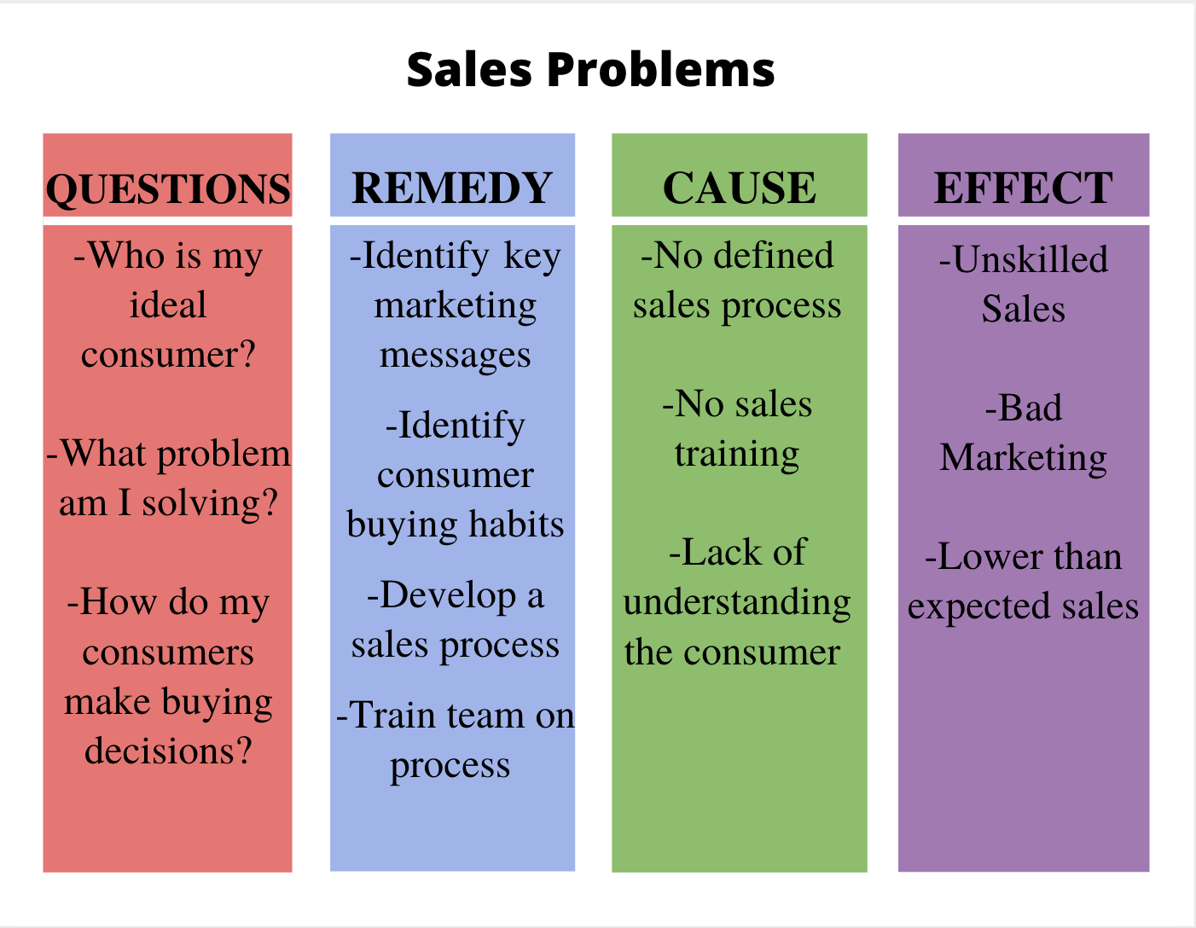
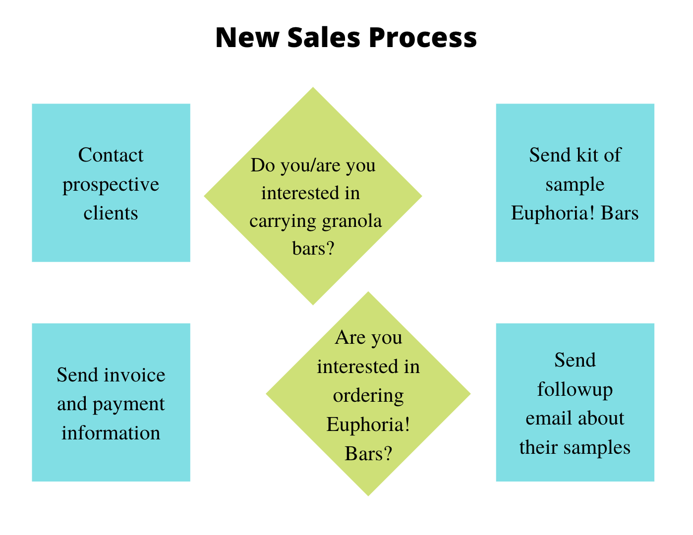

Sales Improvement

Customer:
Target, Walmart, Costco
-Large food retail chain stores
Local PTA, Fundraiser Companies, Mid-Sized Boutiques

Customer Buying Habits:
-Tends to buy in bulk
-Buy at lower prices and tend to resell
-Generally form close and long-term relationships with suppliers
-Reorders products regularly
-Like to have samples in-store (need extra product)
-Sales often depend on industry factors
Market concentration
Growth rate
-Slightly less picky about price increases, as long as there is sufficient consumer demand to balance

Key Marketing Messages:
-Skipping out on breakfast is bad for your body!
-5 Grams of Protein, 200 Calories, and 30 Grams of Carbs: all in one convenient travel-sized bar!
-Never choose between taste and nutrition again!
-Each bar is made with all-natural and fresh ingredients with no added artificial flavorings
-Euphoria! Bars have 3 delicious flavors:
Chocolate Peanut Butter Chunk
Vanilla Blueberry Almond
Honey Chia

Training/Rules for the Improved Sales Process:
-All sales members must wear black or dark-colored dress slacks with button-down Euphoria! Bars polo tucked in when selling to clients
-Sales members are required to ask clients if they want samples
If Yes: provide 1 Box of each flavor of bars and then one week later check-in to see if they would like to buy product
-Maintain good relations with current customers by constantly contacting the company’s correspondents

EMPLOYEE PROBLEMS

Hello Mrs. Allen,
Like I mentioned before the next group of problems I categorized was “people” problems. You mentioned that your main problems were dealing with teamwork, high employee turnover, and family member issues within the firm. Since Euphoria! Bars began as a family business, you have employed lots of family members as your employees. This is already a very delicate problem since it is difficult to just fire or demote family members.

I will say that a reason for your high employee turnover is because your non-family member employees feel unfairly treated within the company. They went through a more rigorous hiring process, aren’t held to higher standards compared to family member employees, and this causes issues with teamwork. In order to fix your problem, I have created a detailed hiring process that allows hiring new employees to be fair and prevents any issues dealing with unfair treatment.

As for the teamwork issue, I researched some team-building activities for your employees. Team building activities allow your employees to get to know each other and work together outside of a work environment. I created a possible company calendar for October through December and included a descriptor of each event. Each month includes at least one team-building activity, ranging from volunteering to holiday parties. These team-building events are crucial in showing that you appreciate your employees and also allowing employees to develop close relations with each other so overall company culture and teamwork improves.

Also on the company calendar, I created a weekly meeting called “Accountability Meetings.” These meetings allows all employees to explain in a group with their respective department head what they have completed in the past week and what they plan to complete in the upcoming week. This way you will know what each employee is doing and what type of progress they are making on projects. This ensures fair treatment for all employees and will also help to improve employee retention.

Wishing you nothing but the best,
EZ Consulting

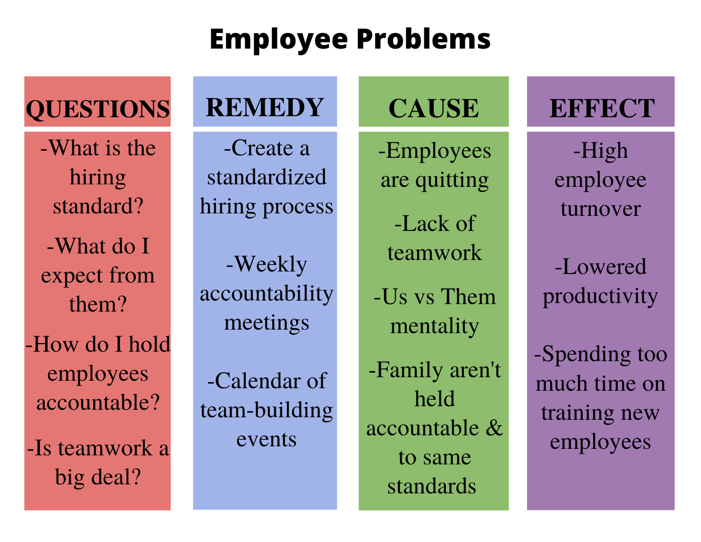

Hiring Process

Basic Principles of Hiring

- Attracting a large pool of candidates increases your chances of finding the perfect candidate for your position.
- By implementing multiple rounds of screening, you will be more efficient since you’re not wasting time with unqualified candidates.
- Knowing the preferences/behaviors of your candidates helps you form an enticing job offer.
- Involving multiple team members in the hiring process allows them to gain support and commitment to the new hire’s success.
- By simulating the job requirements to top candidate’s you can see who will perform best at their given task and thus should be hired.
- It is important to spend personal time ONLY with your top choice candidates.

STEP ONE: Creating a Job Posting
The first to hiring new team members is to encourage as many people as possible to apply for the position. Do not start with the Job Description because before you begin to “eliminate” the candidates, you need to build it up, attract many lockers, and present the open position as a “unique opportunity.”

Begin with an overview of the position then go into the necessary qualifications and attitudes/behaviors you desire.

Job Posting Example
Company Name Position Title
(Company Name) is one of Dallas’ unique, upscale furniture showrooms that cater primarily to the interior design trade. For over thirty-five years we have assisted professional interior designers deliver their signature style to their affluent clients. Our national clientele of interior designers, architects and specifiers rely on (Company Name) for fashion forward upholstery, lighting and furniture as well as our one-of-a-kind and ever-changing collection of antiques, replicas and unique furniture adaptations and creations.
We are seeking to find a (Position Title) capable of building upon our successes and helping us to position (Company Name) as the premier Dallas showroom for the discriminating consumer. This position will begin as part-time but could expand into a full-time position within the first year. This position is primarily responsible for the coordination and management of all activities related to marketing and promotions for the showroom. In addition, this position will assist with the logistics, preparation and execution of events and activities designed for clients, customers and strategic partners.
The individual we are seeking must possess and demonstrate the following critical success behaviors:
• 100% organized, structured and disciplined
• Assertive, aggressive in a positive way, outgoing personality
• Strong communications skills, active listener, problem solver
• Leader, tireless energy, constantly looking for opportunities, taking the lead on new ideas
• Creative, good visual thinker, naturally aware of style, observant
• 24/7 Ambassador for the business
• Sales Oriented, always looking for opportunities to engage with new prospects
Experience with the interior design community and showroom protocols is a plus but it is not essential. We are looking to separate ourselves from other showrooms and are willing to embrace proven strategies that have been successful in other industries and other high-end venues.
Compensation will be determined based upon the experience and skills of the individual selected for the position.
Individuals interested in applying for this position should call the (Company Name) Job Applicant Hotline 1-xxx-xxx- xxxx. This is the first step in our hiring process. Specific instructions on how to begin the process will be found by calling 1-xxx-xxx-xxxx.

STEP TWO: Set up a Job Candidate Hotline
Set up a Job Candidate Hotline – a voice mailbox that will allow the interested job candidates to respond directly and quickly to your job posting. Ask a few questions that you would ask in an interview, and then have candidates respond. This allows you to quickly eliminate unworthy candidates. It is especially time efficient because you can spend your time interviewing truly qualified candidates.

Job Candidate Hotline Custom Greeting Example
Thank you for calling the (Company Name) Job Candidate Hotline. (Company Name) is an award- winning technology and consulting firm specializing in helping associations make technology SIMPLE so they can focus on growing their organization.
We’re growing and current looking to add a (Position Title) to our team. The specific job responsibilities and skill requirements are listed in the job posting.
Our ideal candidate is someone who will quickly become a key team member and someone who our clients and staff will rely on to deliver innovative and timely solutions. We are looking for someone who enjoys being self-managed, can thrive in a work-from-home environment and will become an integral part of a high-functioning team of technical specialists who all work from home.
This is the first step of our application process. If you’re interested in applying for this position, we’ve got three questions we’d like you to answer here on this voice mail message. You’ll have 2 minutes to answer these questions. You may want to grab a pen and paper and write down these questions.
Here are your three questions:
Question #1 – What experiences have you had with configuring and deploying off the shelf business applications?
Question #2 – Describe your experience working with SSRS?
Question #3 – What unique skills and behaviors would you bring to our team?
Please leave your Name, a Contact Phone Number and Contact E-mail and we will get back to you promptly if we are interested in taking you to the next step of our application process.
Thanks again for calling the (Company Name) job candidate hotline. Set up your phone line to send all incoming voicemail messages directly to your email address (and to others who will be involved in the candidate selection process). That way when someone leaves a voicemail message you will immediately receive an email with a voicemail file attached. This allows you to screen incoming voicemail from anywhere at any time!

STEP THREE: Generate Prospective Candidates
After setting up a Job Posting and Job Candidate Hotline, now is the time to post these to a variety of websites to get as much exposure as possible.

Some recommended sites include:

Craigslist GlassDoor Freetrader ZipRecruiter
Indeed Monster Careerbuilder Odesk
Thumbtack Workable SnagaJob Theresumator

In addition to these job posting sites, you should also post on social media, Linkedin, etc. Think outside of the box!

STEP FOUR: Screen the Voicemails You Receive
As soon as you begin receiving voicemails on your Job Candidate Hotline, you can begin to screen them. Look to see if they have followed instructions, if they are pleasant, warm, helpful, enthusiastic, articulate or are they blunt, hard to understand, slow to respond, forgetful, etc. Keep your job posting active for about 1-2 weeks to collect more candidates, then narrow your choices down to about 10-15.

STEP FIVE: Schedule and Hold a Group Interview
After you have narrowed your choices down to around 10-15 candidates, it is time to hold a group interview to determine your top candidates. Send out an interview to ask for candidates to come in for a group interview.

Group Interview Email Example
Thanks for taking the time to respond to our voicemail job candidate hotline.
After reviewing an exceptionally large number of inquiries, we would like to invite you to join us along with a select small group of capable individuals like yourself for an informal get-acquainted session at (time, date, and location).
The purpose of this session is for both of us to determine if we are a good potential fit for each other and whether it makes sense to proceed with in-depth one-on-one personal interviews later on.
Please RSVP by responding to this email. Please include your resume with your response.
We’re eager to share our company vision with you and to get to know about yours.
Kindest regards.

For the interview, I would recommend bringing about 2-3 team members also in the room with you during the interview.

What to Do In the Group Interview...

- Give a 10-15 minute overview of the company.
- Ask candidates your questions for about 30-45 minutes.
- Allow candidates to ask questions they have to your team.
- Share next steps regarding after the interview, notification date and time, etc.
- Say goodbyes & thank the candidates for coming out to the interview!
- Debrief with your own team members to get their opinion on the candidates. This step is crucial in finding out who gets to move on to the next stage.
- Narrow your list down to the top 2-3 candidates.

Possible Questions to Ask During the Group Interview...
• Describe for me the most complicated and difficult customer situation you have had and what made it so difficult.
• Tell me about a situation where you felt that your customer was making a bad decision and you helped them make a better one. How did you do it?
• If you had the opportunity to either work solo or with a large team of people, which would you prefer and why?
• Describe a situation where you identified quality issues, errors or omissions on a job site and tell us how you handled the situation.
• On a scale of 1-10, where would you rate yourself on taking ownership and responsibility for your job and why would you rate yourself there?
• Describe your ideal manager. What do you particularly want from a good manager and what do you really not like at all?
• Share a situation where you had a conflict with a fellow team member and how did you resolve it?
• Thinking back on a previous experience, tell us about a time where you had a slow work day and what you did to make your time more productive and useful?
• If you were to be hired into this position, what skills or behavior would you bring to the position that would be a pleasant surprise to us?

STEP SIX: Administer Individual Assessments
After you have narrowed your list of candidates down to 2-3 people, you should use tools to perform individual assessments on their background.

I would recommend a comprehensive tool like ProfileXT. A good resource for using this particular toolset is www.people-right.com .

STEP SEVEN: Conduct One-on-One Interviews
With your final list of 2-3 candidates, conduct one-on-one interviews to really get to know them better. Now you can spend your valuable time to finalize your list before making the hiring decision.

You’ve already given the company “pitch” and they already know about the position and have even met 1 or 2 of your team members. You can now focus your time on the candidates’ skills, experiences, desires, and aspirations.

STEP EIGHT: Make a Job Offer
You’ve done the hard work, you’ve found a great candidate, now it’s time to close the deal. But you’ve done the good work along the way and they WANT to work with you as much as you want them to say yes! I do recommend you WOW your job candidate and make the job offer a very formal one. I have attached a sample job offer document to this guide. I would recommend you have it reviewed by your legal counsel prior to using it. They may have some specific changes based on your industry, company location, etc.

This Hiring Process Guide was influenced by Mr. Rich Allen (Founder of Tour de Profit).

October-December Team Building Events

Weekly Accountability Meetings
Meetings held with your respective department head at the beginning of every Monday morning reviewing what progress you have made last week and what progress you plan to make in the upcoming week with your department. Please bring documentation of work! We will also discuss each individual team member’s role in the upcoming week to reach weekly goals.
October 2019

Oct 12: Susan G Komen More than Pink Walk
Join your fellow employees as you walk to raise a cure for breast cancer in honor of October being National Breast Cancer Month! The walk will start at 9AM, and all Euphoria! Bars employees should convene in front of the main entrance to walk together. Bring your family and friends to cheer for you at the finish line!

Oct 31: Employee Halloween Party
Euphoria! Bars’ annual employee Halloween party. Costumes and dress-up is recommended but not required; there will be a “Best Dressed” Award. The party provides spooky snacks and refreshments, and it will be held on the first floor of the company’s main lobby.

November 2019
Nov 09: Volunteering at Food Pantry
Give back to our community by volunteering at the local food pantry by making and serving food to the homeless.

Nov 22: Employee Thanksgiving Party
Euphoria! Bars is truly grateful for all that you do as an employee, so as a way of giving thanks to our amazing employees, come celebrate and eat turkey at the annual Thanksgiving party. Party will be held on the first floor of the company’s main lobby.
December 2019

Dec 20: Employee Holiday Party
Our end-of-the-year holiday party features amazing treats, an in-office chili competition, and a raffle award. Celebrate the end of 2019 and the holly jolly holidays with us on the first floor of the company’s main lobby.

